
- Private and Confidential -
May 10, 2016
Peiqi Wang
40 Major Street
Toronto, ON
M5S 2L1
Dear Peiqi:

Welcome to University Health Network!

Please read all of this letter carefully as it forms your employment contract with UHN and also contains important instructions to complete your on-boarding process.
On behalf of Dr. Susan J. Done; I am pleased to confirm our offer of a temporary full-time position as a Summer Student in the Campbell Family Institute for Breast Cancer Research at the Princess Margaret Research Institute commencing May 12, 2016, and ending July 29, 2016. Your rate of pay will be $13.76 per hour. Your continued employment as Summer Student is contingent upon funding being available within the research grant. Your offer is valid for the lesser of the next fifteen (15) business days, or from the date of this letter to your start date. At least 5 days prior to your first day of work you must sign and return this offer letter to Paula Timoteo at Paula.Timoteo@uhn.ca in the Human Resources Administration Department and also to your hiring manager. Doing this allows you to attend orientation and prevents your start date from being delayed.
Things to do before you start your employment with us:
- Please go to UHN’s website (uhn.ca) and follow the For Staff link and then the link For New Employees. Here you will find instructions regarding the forms, processes, information and instructions you will require as a new member of the UHN team. The paperwork for your payroll process as an employee can be found here. Your pay cannot be processed until all these documents are fully completed and returned to our Human Resources Administration department, along with a copy of your Social Insurance Card and birth certificate (or citizenship card or passport). Please complete and bring or e-mail these documents to the Toronto General Hospital, R Fraser Elliot Building, 3rd floor, to the attention of Paula Timoteo at Paula.Timoteo@uhn.ca in the Human Resources Administration Department at least 5 days prior to your start date in order to ensure no delay in your pay.
- In advance of your start date and in preparation for your orientation, there are a number of legislated mandatory on-line learning courses, listed on our website that you must complete.
- You should complete the required elearning courses for Research employees.
- Returning summer students must complete the WHMIS and Fire Safety training, as well as any other courses that have an annual component.
Occupational Health and Safety
All UHN employees must follow safe work practices and comply with the roles and responsibilities that are outlined with respect to health and safety policies, procedures and training at the University Health Network. In accordance with Hospital policy and legislated health and safety requirements, your employment is conditional upon the completion and verification of the Occupational Health Mandatory Requirements.
No later than 5 business days prior to May 12, 2016 (your start date), you must complete Form A: Health History; have your physician complete Form B: Immunization Status Record and return the following forms via email to OHSNEO@uhn.ca.
Please click here for the Occupational Health Mandatory Requirement Package.
Email these documents in a PDF format only, to OHSNEO@uhn.ca for review. Please include the site where you will be working in the subject line of your email. You will be contacted via email by OHS and informed if your occupational health mandatory requirements are complete.
Summer Student Orientation
As a new UHN employee, you must attend our mandatory Summer Student Orientation on May 16, 2016. Please arrive for registration beginning at 8:15 a.m. The session will end by 11:00 a.m. Orientation will be held at the Toronto Rehabilitation Institute- University Centre, 550 University Avenue in the Lecture Theatre. Summer students who completed orientation in 2015 will not have to attend this session.
Probationary Period/ Termination of Employment
All new student employees are required to serve a probationary period of sixty working days in accordance with Hospital policy.
This employment arrangement may be terminated prior to its end date by either party giving the other two (2) weeks’ notice (or pay in lieu of that notice) or the notice required under the Employment Standards Act or relevant collective agreement; whichever is greater. This contract may also be terminated at any time by the Hospital without notice for cause, and in the event of a breach of any of the obligations you are required to observe or perform.
Additional Payroll Documentation
If you find the terms of this offer acceptable, please sign three (3) copies in the space provided. One copy must be returned prior to your start date to the Human Resources Administration Department along with the completed documents indicated above. Return the second signed copy of this offer letter to your hiring manager and retain a copy for your own records.
We look forward to working with you and hope that your employment at UHN will be rewarding to you, the UHN team, and our patients.
Congratulations,
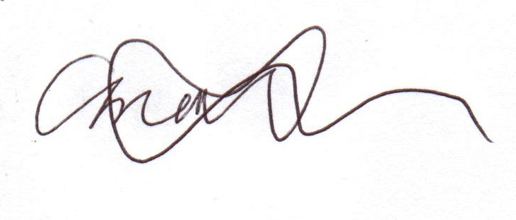
Amal Obeidat
Staffing Advisor
(416) 340-4913
amal.obeidat@uhn.ca
Acceptance:
I, Peiqi Wang, accept this offer of employment in accordance with the terms and conditions described in this letter. I confirm that this agreement constitutes the entire agreement between University Health Network and myself and that any previous agreements, written or oral, express or implied, relating to my employment are hereby void. By signing this offer, I acknowledge that I have received, reviewed, understand, and agree to comply with the Code of Workplace Ethics, the Conflict of Interest Policy, the Privacy Policy, the Confidentiality Agreement, the Conflict of Interest Research Personnel Policy and the Responsible Conduct of Research Policy.

__________________________________________ _______________________
Signature Date

